Lab 42-1 Create an Interactive Flow
Goals | To implement an interactive flow for ABC Company.
Scenario | ABC Company would like Service Representatives to complete service details and create activities each time they modify any open service request record. In the first step to solving this requirement, create an interactive workflow process.
Time | 30 minutes
Instructions:
- If necessary, log in to Siebel Call Center as SADMIN using the Siebel Web Client to view the current application behavior.
  - Select Service > Service Request List > My Service Requests.
  - Drill down on any existing service request.
  - To solve this business requirement, you will need to provide a button on an applet under the Service Details view that takes users to the Service Request Activities view. Select Service Details from the view bar. What is the name of the Service Details View?
  - What is the name of the Detail Applet at the bottom of this view?
  - Select Activities from the view bar. What is the name of the Service Request Activities View?
  - What is the name of the Activity List applet at the bottom of this view?
- Design workflow process that will support the interactive flow.
  - As part of designing this workflow process, describe in your own words what the interactive flow will need to accomplish.
  - ABC has said this requirement is only needed for service requests that have a status of Open. What condition should be set for workflow process, and where in the workflow will you set the condition?
  - ABC wants this workflow to run any time an SR record is created or updated. What runtime event method will be used to invoke the process?
- Create the workflow process in the local development environment.
  - If necessary, log in to Siebel Tools connecting to Local as PPENGUIN/PPENGUIN.
  - Check out ABC Workflow Processes, Activity, and Activity (FS) projects.
  - Create a new workflow process record with the following values:
Process Name | ABC Go To SR Detail Views
Project | ABC Workflow Processes
Business Object | Service Request
Auto Persist | YES
Workflow Mode | Interactive Flow
  - Right-click ABC Go To SR Detail Views and select Edit Workflow Process.
- Create the workflow process steps in the Process Designer.
  - Drag and drop each of the following steps from the palette to the workspace and rename them as indicated:
Step Type | Step Name
Start | START
User Interact | FS SR Detail View
User Interact | SR Detail View
End | END

  - Add Connectors between the steps:
From Step | To Step | Connector Name | Connector Type
START | FS SR Detail View | Status Open | Condition
FS SR Detail View | SR Detail View | Next | Condition
SR Detail View | FS SR Detail View | Back | Condition
SR Detail View | END | End | Condition

  - Your workflow process should look similar to this: 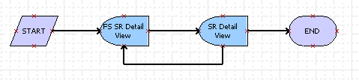
- Add runtime event details.
  - Select the Status Open connector (between Start and FS SR Detail View) and add the following properties:
Event Object Type | Business Component
Event | Write Record
  - Refresh the cache and add the Event Object property to complete runtime event:
    - Right-click in the design workspace and select All Processes.
    - In the list of Workflow Processes, right-click ABC Go To SR Views and select Edit Workflow Process.
    - Select the Status Open branch and set the event object:
Event Object | Service Request
- Add process conditions.
  - Double-click the Status Open branch (between Start and FS SR Detail View).
  - Create the following condition:
Compare to | Business Component
Operation | One Must Match (Ignore Case)
Object | Service Request
Field | Status
Value | Open
  - Click Add to save the conditions.
Note: This will create a runtime event on the Service Request BC to invoke the workflow when an SR is written to the database with a Status of Open.
- Add FS SR Detail View step details.
  - Select the FS SR Detail View User Interact step.
  - In the detail applet, scroll to the right until you see the User Interact View column. Specify FS Service Request Detail View that you identified earlier as the view for this step.
- You will now enter the details to enable forward navigation in the Workflow. When the Next button (to be configured in the next lab) is pressed, the following branch will navigate you to the next step in the workflow.
  - Select the Next branch between the FS SR Detail View and SR Detail View steps.
  - Set the following branch properties:
Name | Next
Type | Condition
Event Object Type | Applet
Event | InvokeMethod
Subevent | FrameEventMethodWFNext
  - To set the Event Object, refresh the cache.
    - Right-click the design workspace and select All Processes.
    - Right-click ABC Go to SR Detail Views and select Edit Workflow Process.
    - Click the branch following the User Interact step.
  - Set the following branch properties:
Event Object | FS Service Request Detail Applet NB
- Add SR Detail View step details.
  - Select the SR Detail User Interact step.
  - In the detail applet, scroll to the right until you see the User Interact View column. Specify Service Request Detail View as the view for this step.
- You will now enter the details to enable backward navigation in the Workflow. When the Back button (to be configured in the next lab) is pressed, the following branch will navigate you to the previous step in the workflow.
  - Select the Back branch between the SR Detail View and FS SR Detail View steps.
  - To continue the workflow, the user will have to hit the Next button again. Set the following branch properties:
Name | Back
Type | Condition
Event Object Type | Applet
Event | InvokeMethod
Subevent | FrameEventMethodWFBack
  - To set the Event Object, refresh the cache.
    - Right-click the design workspace and select All Processes.
    - Right-click ABC Go to SR Detail Views and select Edit Workflow Process.
    - Click the branch following the User Interact step.
  - Set the following branch properties:
Event Object | Service Request Activity List Applet
- You will now enter the details for the branch to finish the Workflow.
  - Select the End branch between the SR Detail View and End steps.
  - To finish the workflow, the user will have to hit the Next button again. Set the following branch properties:
Name | End
Type | Condition
Event Object Type | Applet
Event | InvokeMethod
Subevent | FrameEventMethodWFNext
  - To set the Event Object, refresh the cache.
    - Right-click the design workspace and select All Processes.
    - Right-click Go to SR Detail View and select Edit Workflow Process.
    - Click the branch following the User Interact step.
  - Set the following branch properties:
Event Object | Service Request Activity List Applet
- Validate the workflow process.
  - Right-click the design workspace and select Validate. Address any errors or ask your instructor for assistance.
  - This process just demonstrates the simple action of moving backward and forward between two views. How would you use the techniques used in this lab to create a more complex process?
- Deploy the workflow process..
  - Right-click in the design workspace and select All Processes.
  - Select your workflow process and hit the Deploy button in the OBLE.
  - Check in the ABC Workflow Processes Project.

Lab 42-2 Configure Synthetic Event
Goals | To configure applets involved in the workflow process to use synthetic event buttons.
Scenario | ABC Company would like Service Representatives to complete service details each time they modify any open service request record. The next step to providing a solution is to add a Next button to the FS Service Request Detail Applet NB that will navigate you forward in the workflow and a Back and Done button in the Service Request Activity List Applet that will either move you back or finish the workflow.
Time | 25 minutes
Instructions:
In this lab, you will be adding buttons to two applets to assist user navigation when they create a service request.
FS Service Request Detail Applet NB
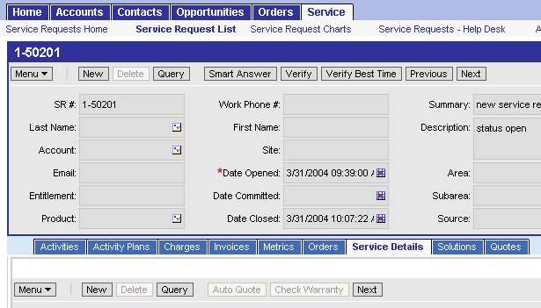
Service Request Activity List Applet
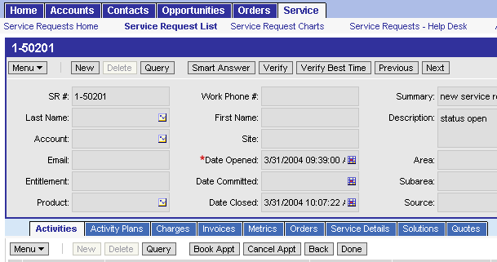
- Add a button labeled Next to the applet you identified in the previous lab.
  - Select Applet : FS Service Request Detail Applet NB | Control.
  - Copy the NewQuery control record and enter the following details to create a Synthetic Events Button Control:
Name | NEXT
Caption - String Reference | SBL_NEXT-1004231538-48J
HTML Type | MiniButton
Method Invoked | FrameEventMethodWFNext
Runtime | Yes
  - Right-click the applet record and select Edit Web Layout.
  - In the Mode: drop down, select 3: Edit.
  - Place the Synthetic Events control button.
    - Locate the control placeholder to the right of the Check Warranty control.
    - Drag the Next control to the placeholder just to the right.
  - Close the Web layout window by selecting Window > Close.
    - Click Yes to save your changes.
- Add a button labeled Next to the applet you identified in the previous lab.
  - Select Applet : Service Request Activity List Applet | Control.
  - Copy the NewQuery control record and enter the following details to create a Synthetic Events Button Control:
Name | Done
Caption - String Reference | SBL_DONE-1004224638-05V
HTML Type | MiniButton
Method Invoked | FrameEventMethodWFNext
Runtime | Yes

  - Copy the Done control for the Service Request Activity List Applet and create a Back control with the following details:
Name | Back
Caption - String Reference | SBL_BACK-1004225019-16A
HTML Type | MiniButton
Method Invoked | FrameEventMethodWFBack
Runtime | Yes

  - Right-click the applet record and select Edit Web Layout.
  - In the Mode: drop down, select 3: Edit List.
  - Place your Synthetic Events Control Buttons.
    - Locate the control placeholder to the right of the Cancel Appt control.
    - Drag the Back control to the placeholder just to the right.
    - Drag the Done control to the placeholder just to the right of Back.
  - Close the Web layout window by selecting Window > Close.
- Click Yes to save your changes
- Compile your changes to the abc.srf.
- Activate the workflow process.
  - Close any open instances of Siebel Call Center.
  - Open ABC Call Center using the icon you created on the desktop.
  - Select File > Connect and login as SADMIN/SADMIN connecting to the Server datasource.
  - Select Administration - Business Process > Workflow Deployment.
  - Query for ABC Go To SR Detail Views and click Activate.
  - Refresh the workflow cache by reloading personalization rules.
    - Select Administration - Personalization > Rule Sets.
    - In the applet menu, select Reload Personalization Rules.
- Test the Synthetic Events.
  - Select Service > Service Request List.
  - Enter a new service request record with the Status of Open, and SADMIN as the Owner.
    - Enter Ctrl+S on your keyboard to save the record. Simply stepping off the record will not commit the record to the database.
    - The runtime event behind the start step should navigate you to the FS Service Request Detail View.
  - Enter some extra SR data in the lower applet.
  - Click Next. The Service Request Detail View should appear.
  - Enter some activities and click Done to finish the workflow.
    - Once you click Done, the workflow process complete. Any further navigation using the synthetic event buttons may result in an error since you are no longer being guided by the interactive workflow process.
  - Now that the workflow process has completed, could you redesign the workflow to finish the workflow using a different Runtime Event?

